_________________________________________

CERTIFICATE OF ATTENDANCE

This Certificate is presented to

Name

The Virtual Forty-Second National HIPAA Summit
February 26, 2025: Certified Cyber Security ArchitectSM (CCSASM) Professional Certification Training & Exam
March 5, 2025: HIPAA Workforce Basic Privacy Training
March 12, 2025: HIPAA Workforce Basic Security/Breach Training
March 19, 2025: HIPAA Summit Workforce Training: HIPAA Transactions, Operating Rules, and
Critical Healthcare Data Exchange Issues
March 25-28, 2025: HIPAA Summit 42

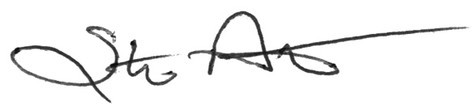
Steve Aitchison
Program Representative
__________________________________________

